Name | Sanchay Ambokar
Roll no | 24204B0046
Batch | 03
Subject name | Python Programming & Data Structure
Teacher Name | Ms. Rasika Patil

Experiments | 3
Title | *a) Develop python program to demonstrate use of control loops:  i) while  ii) do while  *b) Develop program to demonstrate use of for loop in python (e.g.: various pattern building, printing multiplication table, checking palindrome number etc.)
Theory
Looping constructs allow repeated execution of a block of code.
• While Loop runs as long as a condition is true.
• Do-While Simulation is implemented in Python using while True with a break.
• For Loop is used to iterate over sequences or ranges.
These constructs help build logic for patterns, number processing, and iterative operations.
Syntax
• while condition:
• for i in range():
• break
• continue

Here's an explanation of how they work and their significance in solving iterative problems:
1. for Loops:
- for loops are used when you know the number of iterations or when iterating over a sequence (e.g., lists, tuples, strings).
- They iterate over each item in a sequence, executing a block of code for each Iteration.

Syntax | Example
for item in sequence:  # Code block to execute for each item | numbers = [1, 2, 3, 4, 5]  for num in numbers:  print(num)
2. while Loops:
A while loop is used to repeatedly execute a block of code as long as a specified condition is true. It continues iterating until the condition becomes false.
Syntax | Example
while condition:  # Code block to execute while condition is true | num = 1  while num <= 5:  print(num)  num += 1

3. Nested Loops:
You can nest loops within each other to perform more complex iterations, such as iterating over nested lists or performing matrix operations.
Syntax | Example
for outer_variable in outer_sequence:  table # Code block for the outer loop for rows  inner_variable in inner_sequence:  # Code block for the inner loop space | # Nested loops to create a multiplication  for i in range(1, 6): # Outer loop for the  for j in range(1, 6): # Inner loop for the columns  print(i * j, end='\t') # Print the product with a tab  print() # Print a new line after each row

Loop Control Statements:
Python provides loop control statements to modify the behavior of loops:
- break: Terminates the loop prematurely, exiting the loop entirely.
for i in range(5):
if i == 3:b
break print(i)
- continue: Skips the rest of the current iteration and moves to the next iteration. for i in range(5):
if i == 3:
continue print(i)
- pass: Placeholder that does nothing. It is used when a statement is syntactically required but no action is needed.
for i in range(5):
pass # Placeholder for future code

Programming Questions with Answer
FOR LOOP
1 | Print multiplication table of a number
SCRIPT | n = int(input("Enter a numbers:"))  for i in range (1,11):  print(n, "x", i, "=", n * i)
OP | 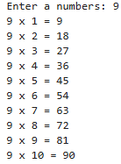
2 | Print a star pattern
  *  **  ***  ****  ***** | *  ***  *****  ***  * | 1010101  10101  101  1
SCRIPT | for i in range(1,6):  print("*" * i)  for i in range(5,0,-1):  print("*" * i)  print("----------")  n=5  mid=n//2  for i in range(mid+1):  print(" " * (mid-i)+"*"*(2*i+1))  for i in range(mid-1,-1,-1):  print(" " * (mid-i)+"*"*(2*i+1))  for i in range(7,0,-2):  print("10" * (i //2) + "1")
OP | 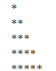  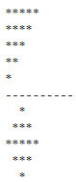  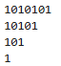
3 | Count digits in a number
SCRIPT | num = input("Enter a number: ")  count = 0  for digit in num:  count+=1  print("Number of digits:", count)
OP | 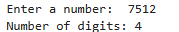
WHILE LOOP
1 | Print numbers from 1 to 20
SCRIPT | i =1  while i<=20:  print(i)  i+=1
OP | 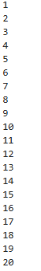
2 | Sum of digits of a number
SCRIPT | num = int(input("Enter a number: "))  sum = 0  while num>0:  sum+=num %10  num //=10  print("Sum of digits =", sum)
OP | 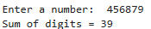
3 | Reverse a number
SCRIPT | num = int(input("Enter a number: "))  rev = 0  while num>0:  rev = rev * 10 + num % 10  num//=10  print(rev)
OP | 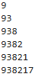
4 | Program to check if a number is a palindrome using for loop
SCRIPT | num = input("Enter a number: ")  rev = ""  for i in num:  rev = i + rev  if num == rev:  print("Palidrome number")  else:  print("Not a Palidrome")
OP | 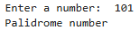
DO-WHILE SIMULATION
1 | Keep taking input until the user enters 0
SCRIPT | while True:  n = int(input("Enter a Number (0 to stop):"))  if n==0:  break  print("you entered: ",n)
OP | 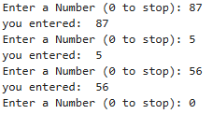
2 | Menu-driven calculator
SCRIPT | while True:  print("1.Add 2.Substract 3.Multiply 4.Exit")  ch = int(input("Enter choice:"))  if ch == 4:  break  a = int(input("Enter first Number: "))  b = int(input("Enter second Number: "))  if ch == 1:  print("Sum = ",a+b)  elif ch == 2:  print("Difference = ",a-b)  elif ch == 3:  print("Product = ",a*b)
OP | 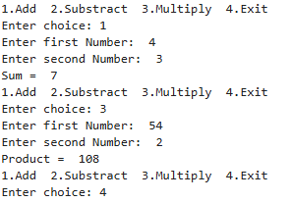
3 | Continue asking for password until correct
SCRIPT | correct_password = "python"  while True:  pwd = input("Enter Password: ")  if pwd == correct_password:  print("Access granted")  break  else:  print("Incorrect password")
OP | 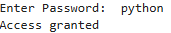
Debugging Questions with Corrected Answers
1 | Debug the following code  Wrong code:  i = 1  while i <= 5  print(i)  i = i + 1
OP | Error: SyntaxError: expected ':'  IndentationError: expected an indented block after 'while' statement on line 2  Correct code:  i = 1  while i <= 5:  print(i)  i = i + 1
2 | Debug the following code  Wrong code:  for i in range(1, 10)  print(i)
OP | Error: SyntaxError: expected ':'  Correct code:  for i in range(1, 10):  print(i)
Conclusion | This practical helped understand the use of for, while, and do-while (simulation) loops in Python. It improved logical thinking and showed how loops simplify repetitive tasks and control program flow efficiently.
Performance Indicators |  | Teachers Dated and Signature
Process Related  (15 M) | Product Related  (10 M) | Total (25 M)

